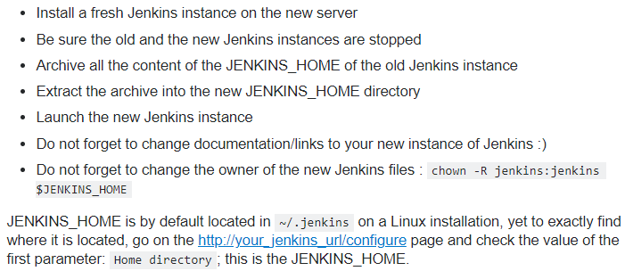

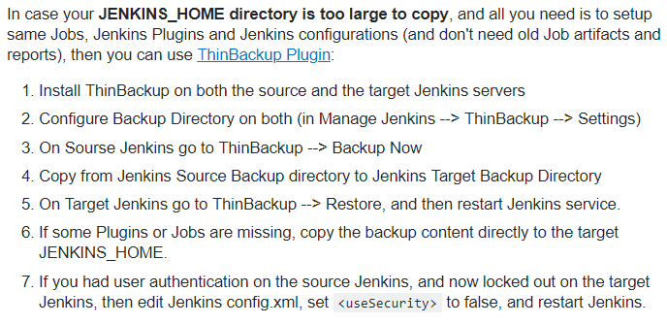

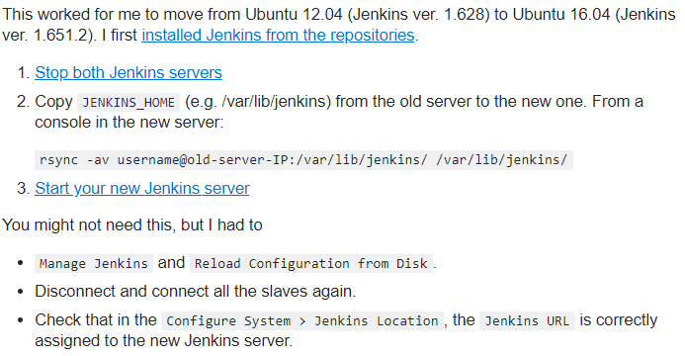



**This works the same way if we want to move a job from one Jenkins instance to another**

**Go to the “JENKINS_HOME/jobs” folder where the Jenkins stores all the jobs related data. We can see the job names in this directory**

**Copy whatever the job folder we want to move and paste it in other Jenkins instance $JENKINS_HOME/jobs directory**